# Computer Vision Hw10 Report

* Discription
  + Zero Crossing Edge Detection
* Algorithm
  + Laplace, Minimum variance Laplacian, Laplace of Gaussian, Difference of Gaussain edge detectors.
  + Kernel : same as website
* Parameters (if any)
  + no
* Principal Code Fragment

Main (file – /src/hw10/ DemoZeroCrossingEdgeDetection.java)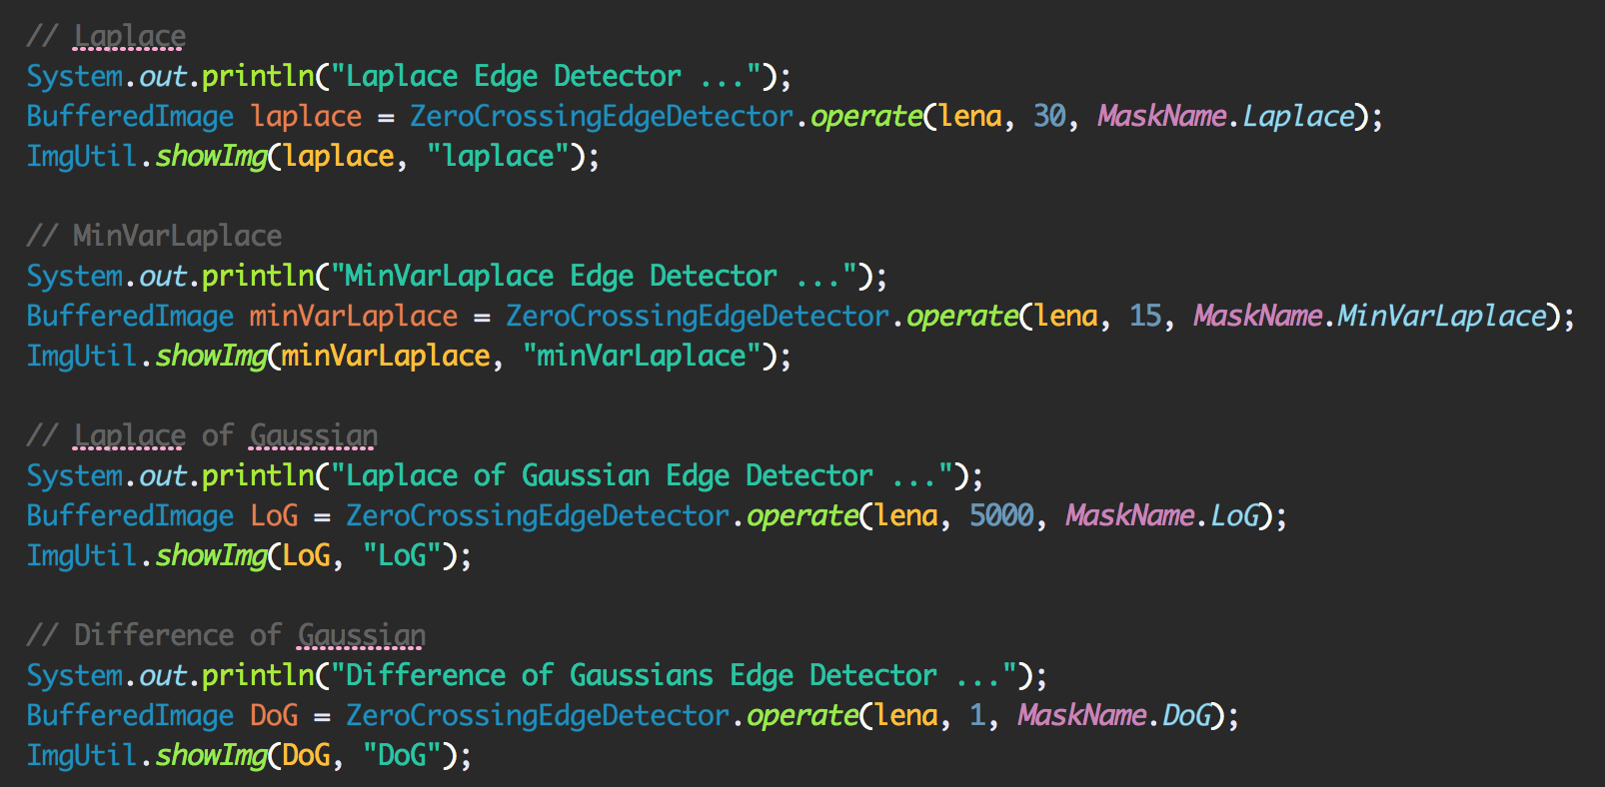

GeneralEdgeDetector

(file – /src/cv1.util.cv.edge /ZeroCrossingEdgeDetector.java)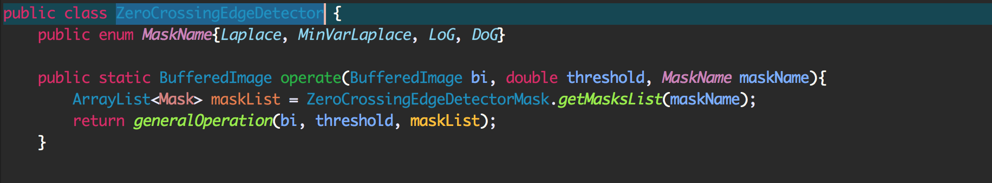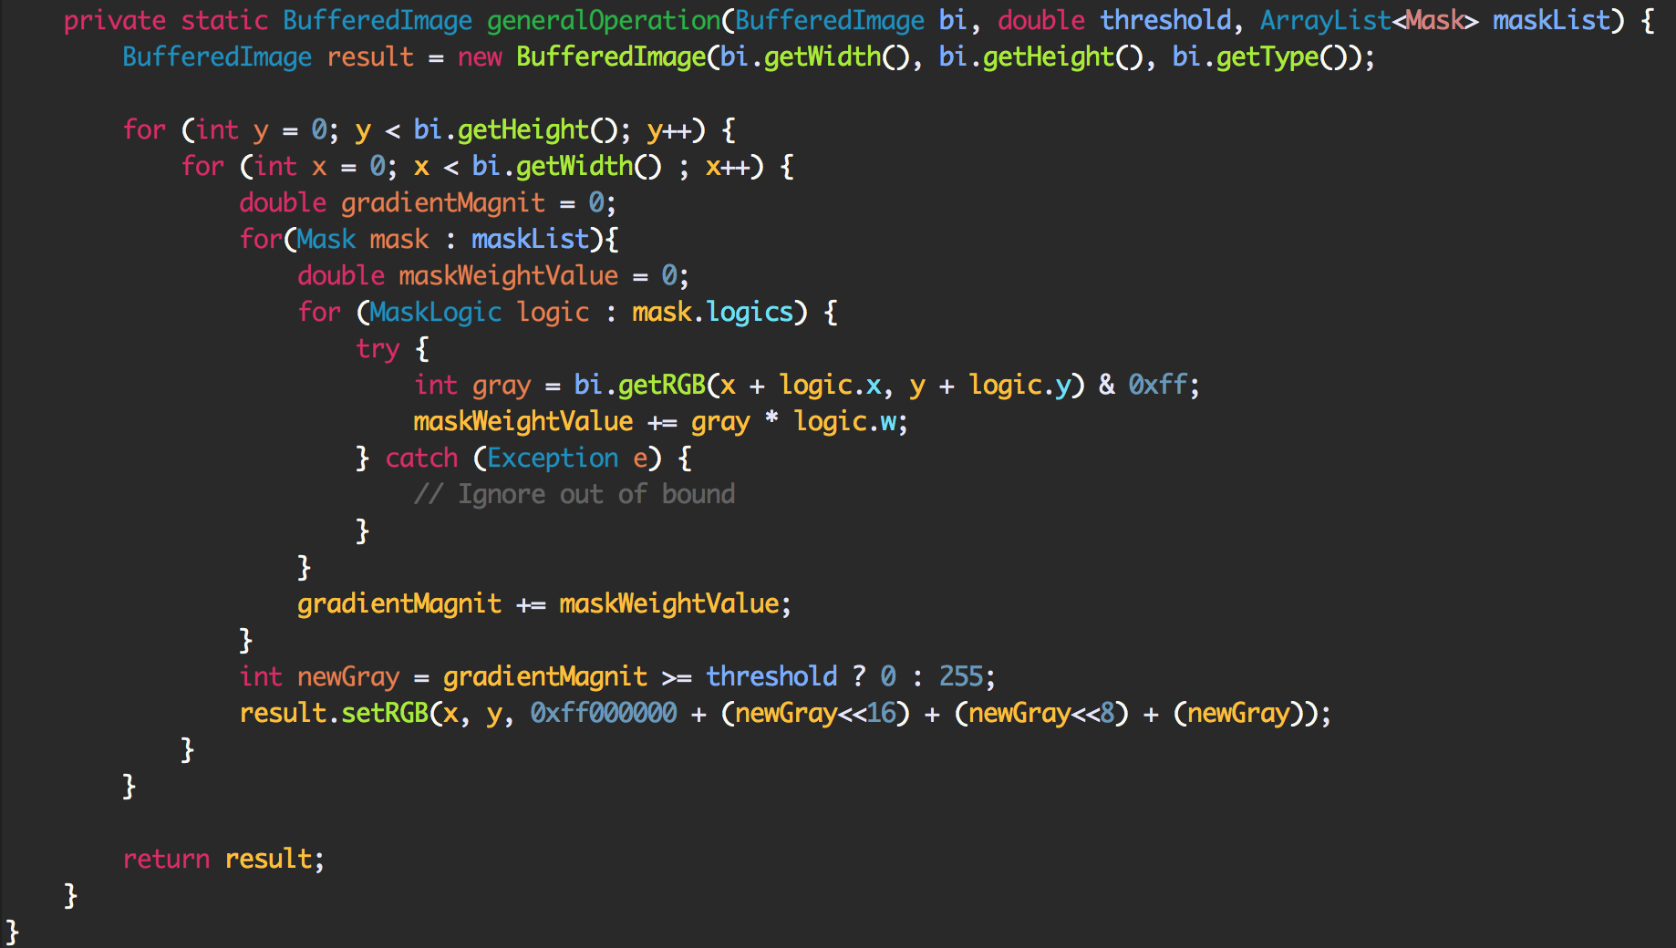

* Result Image

Laplace (threshold = 30) MinVarLaplace (threshold = 15)

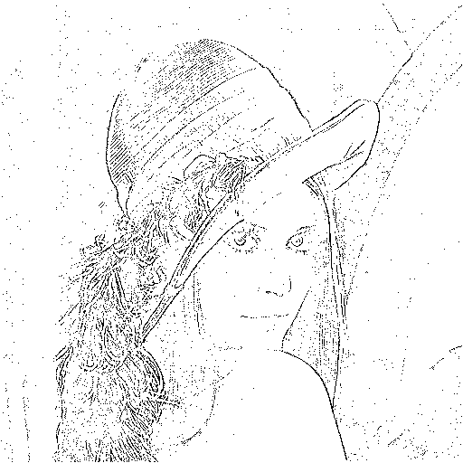 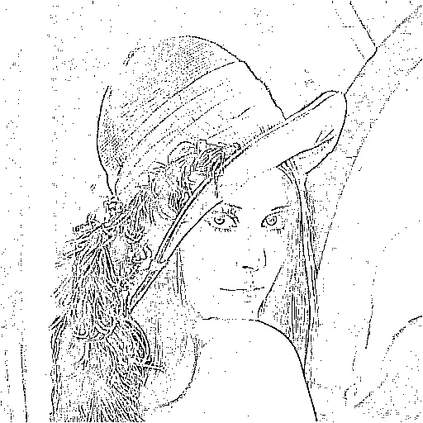

LoG (threshold = 5000) DoG (threshold = 1)

